How Default Tip Options Shape Tipping Decisions: A Randomized Survey Simulation
Linh Le, TzuHsuan Liu, Kang Ni, Shanmath Sivakumar, Hanchao Tang
03/05/2025

Executive Summary
Tipping prompts have become a common feature of digital restaurant payment systems in the United States. Many payment terminals present suggested tip percentages, which may act as behavioral anchors that influence consumer decisions. This study examines whether increasing default tip suggestions leads customers to select higher tip amounts during checkout.
We conducted a randomized survey experiment using a simulated restaurant payment scenario. Participants were asked to imagine dining at a restaurant and were shown a payment screen for a fixed $16 meal. Respondents were randomly assigned to one of two conditions: a control group that saw tip options of 15%, 18%, and 20%, and a treatment group that saw higher suggested tips of 18%, 20%, and 25%. The primary outcome variable was the tip percentage selected by the participant. Additional demographic and behavioral variables, including years lived in the United States, dining frequency, and service industry experience, were collected to improve estimation precision and explore heterogeneity in responses.
The results show that increasing the default tip suggestions did not meaningfully change the average tip percentage selected. Across both groups, most participants chose tip values clustered around 15–18 percent, and regression estimates indicate that the treatment effect is close to zero.
These findings suggest that simply raising default tip options may not significantly influence tipping behavior in isolation. For restaurants and payment platforms seeking to increase tips, alternative strategies such as emphasizing social norms, highlighting recommended tip levels, or experimenting with interface design may be more effective than adjusting default percentages alone.

Introduction
Tipping prompts have become a standard feature of restaurant payment terminals in the United States. Digital checkout systems frequently display suggested default tip percentages, and these defaults may serve as behavioral anchors that shape consumer decisions. Rather than calculating a tip from scratch, many customers rely on the pre-set options presented on screen.
Understanding whether higher default tip suggestions increase tipping behavior has important economic implications. If small changes in framing meaningfully affect generosity, restaurants and payment platforms can influence income distribution between consumers and service workers without altering wages or service quality. Our study examines this effect in a realistic dine-in restaurant checkout scenario that closely mirrors common payment terminals.
Research question
How does showing higher default tip suggestions affect the tip percentage selected in a simulated dine-in restaurant checkout?
Hypotheses
Showing higher default tip suggestions increases the tip percentage selected.
H0: There is no effect of showing higher default tip suggestions on the tip percentage selected.
Ha: There is an effect of showing higher default tip suggestions on the tip percentage selected.

Experimental Design

Participants and recruitment
Participants were recruited using a convenience sample drawn primarily from our classmates and personal networks. The study was administered online using Qualtrics, which also handled random assignment to experimental conditions. Respondents provided demographic information (e.g., age, race, years lived in the U.S.) and completed the dining simulation and payment-screen task described below. We excluded responses generated in Qualtrics “preview” mode during survey testing and excluded incomplete responses. After applying these exclusions, the final analytical sample contained 81 participants.

Procedure
Participants completed a brief dining-experience simulation based on a scripted description of a typical restaurant visit (greeting, order, food delivery, and one check-in). To standardize the decision context, all participants were told they ordered the same item (Tonkatsu ramen) priced at $16.00. Immediately afterward, they viewed a checkout screen and selected a tip from preset options. They then answered a short set of post-experience questions on tipping beliefs and dining frequency before submitting the survey. Prior to launching the final survey, we ran a small pilot (7–10 respondents) to check the flow and clarity of the scenario and payment screen, and made minor wording adjustments to reduce confusion..

Treatment and randomization
The experimental manipulation was the set of default tip options shown on the payment screen. All participants saw the same dining scenario and the same bill amount ($16.00). The only element that differed across conditions was the set of suggested tip buttons

Condition | Tip options shown on payment screen
Control | 15% , 18% , 20% , plus an “Other/custom” option
Treatment | 18% , 20% , 25% , plus an “Other/custom” option

Unit of randomization: The unit of randomization was the individual respondent.
Randomization mechanism: Random assignment was implemented inside Qualtrics using the built-in randomizer, which routed each participant to exactly one of the two payment-screen versions. Randomization occurred immediately before the payment screen, after participants viewed the standardized dining scenario.The study used approximately equal allocation across arms.

Outcomes
- Primary outcome: The primary outcome was the tip choice on the payment screen, measured as tip percentage. Participants selected one of the preset tip options shown on the screen. For analysis, all responses were converted into a single continuous variable(Tip_Percent). When participants entered a custom amount, the response was standardized into a percentage so that preset and custom entries could be analyzed together.
- Secondary outcomes: In addition to the tip choice, we measured participants’ tipping attitudes and beliefs using two Likert-scale items:
(i) agreement that tipping plays a role in how restaurant workers are compensated
(ii) agreement that restaurant staff compensation should primarily come from wages paid by employers.
These were analyzed descriptively and were also used to explore whether the treatment effect differed across respondents with different tipping beliefs.

Covariates collected
We collected a small set of background variables to describe the sample and to improve the precision of our estimates. The covariates included are:
- Age
- Race
- Years lived in the United States (as a proxy for familiarity with U.S. tipping norms)
- Service-industry experience (whether the respondent has ever worked in the service industry)
- Dining frequency (how often the respondent dines in at restaurants)
We use these variables in two ways. First, we include them as controls in some regressions to reduce noise and improve precision. Second, we use them to explore whether the effect of higher default tip suggestions differs across groups.
Data Processing and Summary Statistics

Cleaning and exclusions
The raw Qualtrics dataset was cleaned to ensure that only valid and complete survey responses were included in the analysis. Observations labeled “Survey Preview” were removed, and only responses with Progress = 100% were retained to exclude incomplete surveys. After these filtering steps, the dataset index was reset to create a clean working dataset. A binary Treatment indicator was then constructed to identify respondents exposed to the higher default tipping screen. Because the control and treatment survey versions used separate question columns, responses were merged into a unified structure using combine_first so that all variables followed the same format across conditions. Missing values were not imputed; observations with missing values were excluded only when necessary for specific analyses.

EDA
Exploratory data analysis was conducted to summarize key demographic, behavioral, and attitudinal variables in the dataset. Bar charts were generated for several variables, including age group (QID2), race (QID3), years lived in the United States (QID4), dining frequency (QID6), and attitudes toward tipping and restaurant worker compensation (QID8 and QID10). These visualizations provide a descriptive overview of the sample and illustrate how responses are distributed across participants. The charts for tipping attitudes (Figure 1) show that many respondents believe tipping plays an important role in restaurant worker compensation, with responses clustering around the middle-to-agree range (levels 3–5). Similarly, a majority of respondents expressed agreement with the statement that restaurant staff compensation should come primarily from wages paid by employers, with the highest share selecting “Strongly Agree.” This suggests that participants generally recognize the role of tipping while also supporting wage-based compensation systems.
The distribution of survey completion time (Figure 2) was also examined to assess response behavior. Survey durations were categorized into four bins: <20 seconds, 20–60 seconds, 60–180 seconds, and >180 seconds. Responses completed in under 20 seconds were treated as potentially inattentive and were not considered in the interpretation of survey duration patterns, as such short completion times may indicate that the survey was not answered carefully. The majority of responses fall within the 20–180 second range, suggesting that most participants spent a reasonable amount of time completing the survey.

Randomization Check
Randomization checks assessed whether assignment to treatment versus control was consistent with the intended design and whether key baseline covariates were balanced across conditions. The realized allocation included 81 respondents total, with 47 in control (58.02%) and 34 in treatment (41.98%); a chi-square test comparing observed group sizes to an equal split produced p = 0.149, indicating no statistically significant deviation from the expected allocation. Balance across observable covariates was evaluated using chi-square tests of independence. Age group (QID2) was well balanced across conditions (χ² = 0.852, p = 0.837) and years lived in the U.S. (QID4) was also well balanced (χ² = 1.643, p = 0.440). These results indicate no detectable baseline differences between treatment and control on the covariates tested, supporting the validity of the random assignment.
Methodology

Building on the experimental design and the descriptive patterns documented in the Data and EDA sections, our methodology uses the randomized structure of the dataset to quantify the causal effect of tip defaults. Because assignment to the control versus higher-default tip menu is random, differences in the selected tip percentage (Tip_Percent) can be attributed to the change in suggested defaults rather than differences in respondent characteristics. The models below formalize this comparison, first with a simple treatment–control regression and then with specifications that add pre-treatment covariates and interaction terms to improve precision and assess heterogeneity.

Simple Linear Regression: To estimate the average treatment effect (ATE) of higher default tip suggestions on tipping, we fit a baseline OLS model where (Treatment_i) indicates assignment to the higher-default condition:

Regression with Covariates: Although randomization ensures unbiased estimation without controls, we add pre-treatment covariates to improve precision. We estimate:

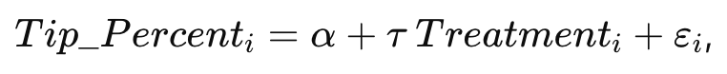
where (X_i) includes age group, years living in the U.S., service-industry experience, and dining frequency (entered as categorical indicators). Robust (HC1) standard errors are used for inference.

Heterogeneity:To test whether the treatment effect differs across respondent characteristics, we estimate interaction models of the form:

We test heterogeneity using pre-treatment moderators such as U.S. experience (e.g., lived in the U.S. ≥5 years) and tipping-pay attitudes (Likert items coded as numeric).

Results
In our baseline treatment–control regression (N=81), the control group’s average tip is about 15.3%, and the estimated treatment effect is essentially zero (0.002, i.e., +0.2 percentage points) with a relatively large standard error (0.012). This indicates that, in our simulated restaurant checkout setting, shifting the suggested tip defaults did not meaningfully change the tip percentage selected on average in this sample(Figure 3).
In our regression with covariates, after controlling for pre-treatment characteristics (age group, years in the U.S., service-industry experience, and dining frequency), the estimated treatment effect remains close to zero (0.008 with SE 0.012), consistent with the baseline model—changing the suggested tip defaults does not materially shift the average tip percentage in this sample. The covariates help explain some variation in tipping (R² ≈ 0.159), with respondents who have lived in the U.S. ≥5 years tipping modestly more than the reference group, while most other controls show small, imprecise differences(Figure 4).
Regression with heterogeneity: We next test whether the treatment effect differs by respondent characteristics by interacting treatment with U.S. experience (US ≥5 years) and tipping/pay attitudes (Likert-coded measures). The interaction terms are small and not statistically significant, indicating no clear evidence that the default-tip manipulation works differently across these subgroups in our data. The main effects suggest baseline differences by U.S. experience (US ≥5 years associated with higher tipping), but the treatment itself and its interactions remain imprecisely estimated(Figure 4).
The two groups look broadly similar, with most tips concentrated around 15%–18% and no clear upward shift in the treatment group. In both conditions, participants usually chose the lowest preset option; under control (15/18/20) a noticeable share still selected 18%, while under treatment (18/20/25) most participants selected 18% and few chose 20% or 25%. A plausible explanation is that raising the minimum from 15% to 18% moves some prior 15% choosers up to 18%, but also pushes others to use “customise” to enter tips below 18% (including some very low values), which can offset the upward movement and keep the average tip similar across groups. Additionally, 25% may be too large a jump to attract many selections; a smaller top option (e.g., 22%) might generate more uptake at the high end(Figure 5).

Business Insight
Increasing the default tip from 15% to 18% alone has limited impact on tipping behavior. For solution and recommendations:
- Restaurants and payment platforms should leverage social norms and informational nudges that emphasize the importance of tipping for worker compensation. Messaging such as “Most customers tip 20%” or providing recommended tip ranges may be more effective in increasing tip amounts than simply adjusting default options.
- The tips selection interface offers various design options, such as: highlight options, background design, animation effects, bonus screens, scrolling designs, etc.
- Restaurants can run small-scale A/B experiments directly through their point-of-sale (POS) systems to identify which tipping interface leads to higher tip amounts. Instead of relying on a fixed default tip percentage, restaurants can randomly assign customers to different tipping screen designs and compare the outcomes.
Limitations
- Convenience sample (BU students)
  - The participants were primarily BU students, which may not represent the broader population of restaurant customers. Students often have different income levels, tipping habits, and social norms compared with the general population.
- Hypothetical payment (no real money at stake)
  - Participants were asked to choose tipping options in a simulated scenario rather than making an actual payment. Because there was no real financial consequence, participants may have been more willing to select higher tip amounts than they would in a real restaurant setting.
- Video realism / demand effects
  - The tipping interface was shown through a video or simulated environment rather than a real payment terminal. Participants may have inferred the purpose of the experiment and adjusted their behavior accordingly (demand effects), which could bias the results.
- Limited power / multiple testing
  - Our sample size is relatively small, the experiment may lack sufficient power to detect smaller but meaningful differences in tipping behavior.
- Context-specific behavior (restaurant vs survey context)
  - Tipping behavior is highly context-dependent. Factors such as service quality, waiter interaction, group dining, alcohol consumption, and bill size can all influence tipping. Because the experiment isolates only the tipping screen, it may not capture these real-world influences.

Conclusion
This study examined whether higher default tip suggestions influence the tip percentage selected in a simulated restaurant checkout. Using a randomized survey experiment, participants were assigned to either a standard tip menu (15%, 18%, 20%) or a higher-default menu (18%, 20%, 25%) and asked to choose a tip after a dining scenario. The results show that increasing the suggested tip defaults did not meaningfully change the average tip percentage in our sample. These findings suggest that simply adjusting default tip options may have limited influence on tipping behavior, and that other mechanisms such as social norm messaging or interface design may be more effective in encouraging higher tips.

Appendix

Links to Analysis on Google Colab:
https://colab.research.google.com/drive/1AlNLLV_zlx0PMqZ5gzmsAGTJB2AkHc6s?usp=sharing

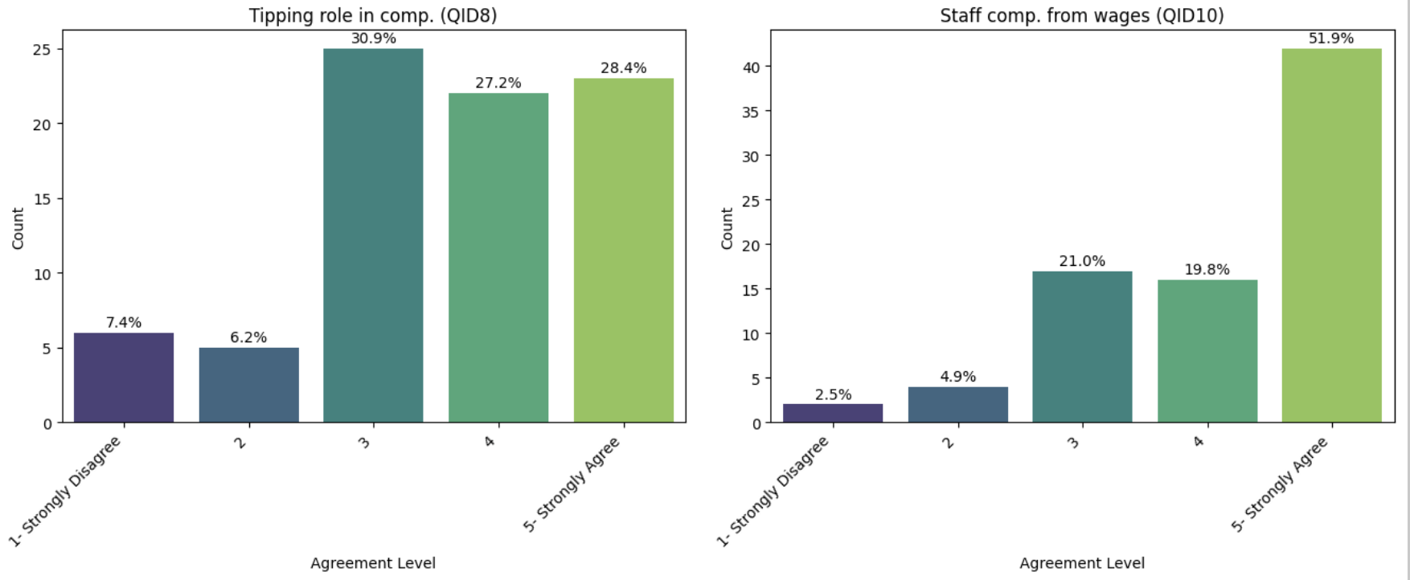
Figure 1: Analysis of Demographic, Dining Behavior, and Tipping Attitude

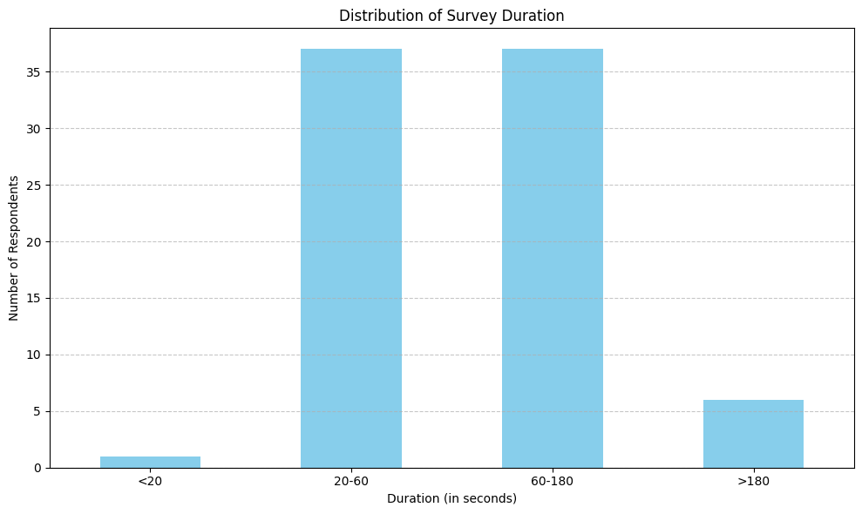
Figure 2: Distribution of Survey Duration
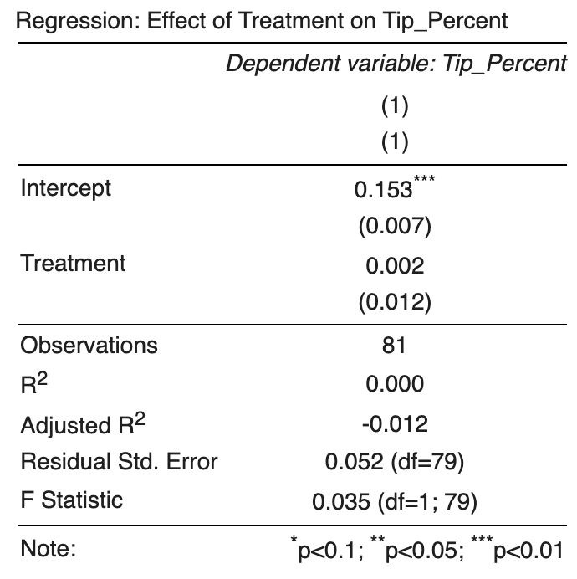
Figure 3: OLS Regression Results Table

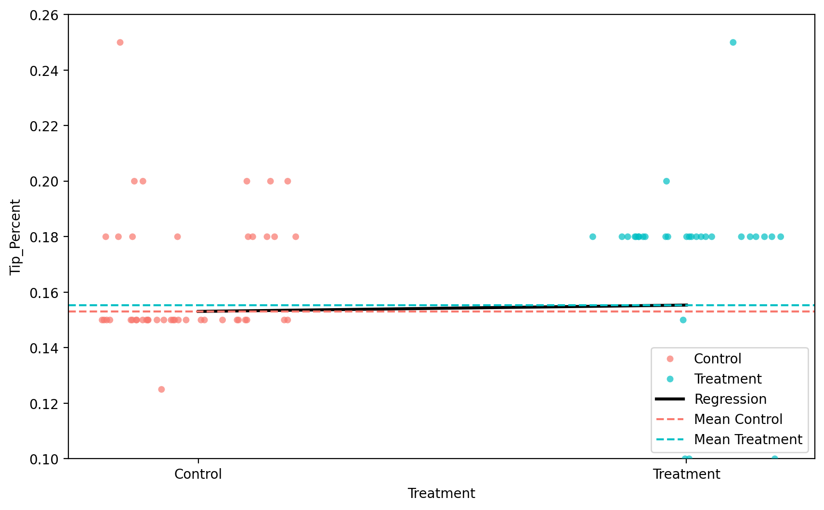
Figure 4: Regression Results Table with Covariates and Heterogeneity
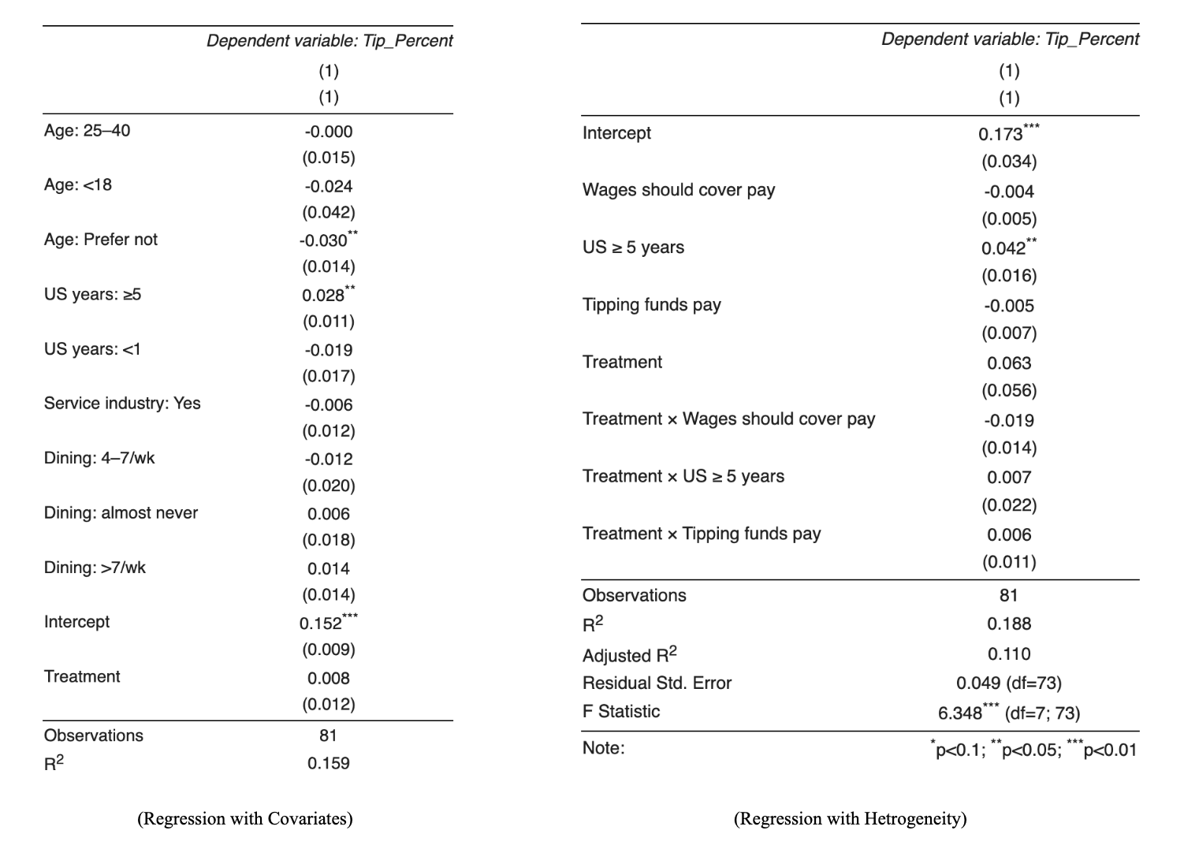
Figure 5: Linear Regression Plot (Y-axis limits to 0.1 - 0.26)

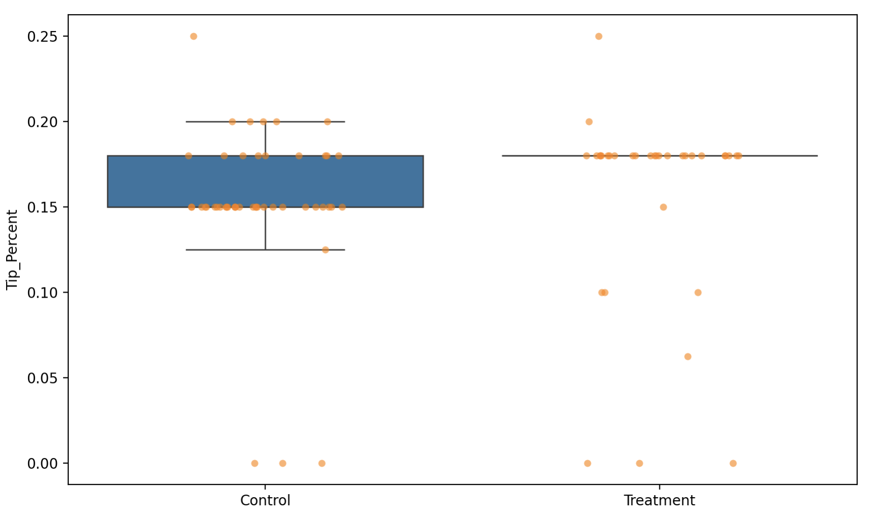
Figure 6: Distribution of Tipping by Control and Treatment

Dining Experience Simulation Study
Start of Block: Block 2
Dining Experience Simulation Study Participants will view a short simulated restaurant visit and answer questions about their impressions and choices during the experience.
Arrival Experience Your server will greet you, take your order, and deliver your food in a timely manner. They will check in once during the meal to ensure everything is satisfactory and respond to any requests as needed. The interaction is professional, courteous, and efficient. Menu & Meal: You chose the Tonkatsu Ramen. Solid choice! Tonkatsu Ramen (とんかつら麺) – $16.00 Traditional Japanese-style ramen served with pork broth, wheat noodles, sliced pork, green onions, and a soft-boiled egg. Prepared fresh and served hot.
End of Block: Block 2
Start of Block: Control Group: Default 15% Tip
How much would you tip?
- 15% ($2.40). Total: $18.40 (1)
- 18% ($2.88). Total: $18.80 (2)
- 20% ($3.20). Total: $19.20 (3)
- Customise (4) __________________________________________________
How old are you? (Numerical values only)
- Below 18 (1)
- 18 - 25 (2)
- 25 - 40 (3)
- Above 40 (4)
- Prefer not to say (5)
What is your race?
- White (1)
- Black or African American (2)
- American Indian or Alaska Native (3)
- Asian (4)
- Native Hawaiian or Pacific Islander (5)
- Other (6) __________________________________________________
- Prefer not to say (7)
How long have you lived in the US?
- <1 year (1)
- 1–5 years (2)
- 5+ years (3)
Are you working or have you ever worked in the service industry?
- Yes (1)
- No (2)
How often do you dine in at a restaurant?
- I almost never go to restaurants. (1)
- 1-3 times a week (2)
- 4-7 times a week (3)
- More than 7 times a week (4)
Tipping plays a role in how restaurant workers are compensated.
- 1- Strongly Disagree (1)
- 2 (2)
- 3 (3)
- 4 (4)
- 5- Strongly Agree (5)
Restaurant staff compensation should primarily come from wages paid by employers.
- 1- Strongly Disagree (1)
- 2 (2)
- 3 (3)
- 4 (4)
- 5- Strongly Agree (5)
End of Block: Control Group: Default 15% Tip
Start of Block: Treatment Group: Default 18% Tip
How much would you tip?
- 18% ($2.88). Total: $18.88 (1)
- 20% ($3.20). Total: $19.20 (2)
- 25% ($4.00). Total: $20.00 (3)
- Customise (4) __________________________________________________
Q23 How old are you?
- Below 18 (1)
- 18 - 25 (2)
- 25 - 40 (3)
- Above 40 (4)
- Prefer not to say (5)
What is your race?
- White (1)
- Black or African American (2)
- American Indian or Alaska Native (3)
- Asian (4)
- Native Hawaiian or Pacific Islander (5)
- Other (6) __________________________________________________
- Prefer not to say (7)
How long have you lived in the US?
- <1 year (1)
- 1–5 years (2)
- 5+ years (3)
Are you working or have you ever worked in the service industry?
- Yes (1)
- No (2)
How often do you dine in at a restaurant?
- I almost never go to restaurants. (1)
- 1-3 times a week (2)
- 4-7 times a week (3)
- More than 7 times a week (4)
Tipping plays a role in how restaurant workers are compensated.
- 1- Strongly Disagree (1)
- 2 (2)
- 3 (3)
- 4 (4)
- 5- Strongly Agree (5)
Restaurant staff compensation should primarily come from wages paid by employers.
- 1- Strongly Disagree (1)
- 2 (2)
- 3 (3)
- 4 (4)
- 5- Strongly Agree (5)
End of Block: Treatment Group: Default 18% Tip

